Start Script:

Step 1:

Step 2:

Step 3:

Step 4:

Step 5:

Step 6:

Step 7:

Step 8:

Step 9:

Step 10:

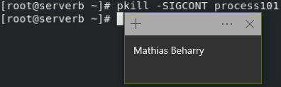

Step 11:

Step 12:

Evaluation Script & Finish Script:

